# Help File

## Description of Project Files

|  |  |
| --- | --- |
| Help File | Explains useful information on the project such as passwords, setup, explanation of documents and design process |
| Sql Explanation | Contains SQL code used to create the database and its queries. Each snippet of code is given an explanation on what it does and why |
| Database SQL Export | Contains the exported SQL code from the final databases tables, relationships, and views, ready to be imported |
| Slack Collaboration | Contains evidence of team’s use of Slack with screenshots to support teamwork and communication |
| AWS | Contains externally hosted database |
| Demonstration Video | Explanation on how the database functions and how SQL commands are used to manipulate database data |
| Development Video | Explanation of how database was planned, developed and implemented to AWS |
| Contribution Report | Includes the level of contribution to the project for each member of the group |

## **Setup**

### Getting the database on your device

The following instructions explain setting up, navigating, and using the database in localhost/phpMyAdmin.

First, download the file to your device. The file will be a zip file (shown in fig. 1). Unzip the file to the location of your choice. After this, you will see the folder contents shown in fig. 2.



Fig 1

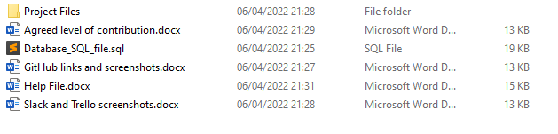

Fig 2

To set up the database in localhost, you will need to use the contents of Database_SQL_file.sql. You will also need to ensure that WampServer64 is running on your device. To do this, check that the WampServer logo in the bottom right corner of your screen is showing as green as shown in fig. 3. If the logo is orange or red as shown in fig. 4, there is an issue with your wamp services, meaning that either you have not successfully launched WampServer or there is an issue with your install, and troubleshooting will be required before proceeding.



Fig 4

Fig 3

Once you have Wamp running successfully you can open localhost in the browser of your choice. When you open phpMyAdmin, you will be greeted with a login screen as shown in fig 5. Enter the username “root” and leave the password empty. You will then be brought to phpMyAdmin.

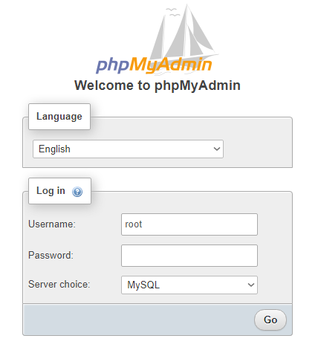

Fig 5

You will now need to create the required database on your device. You can do this by clicking “New”, as highlighted in fig 6, then entering a database name (for example, group_12_db) into the “Database name” field as highlighted in fig 6, then clicking create.

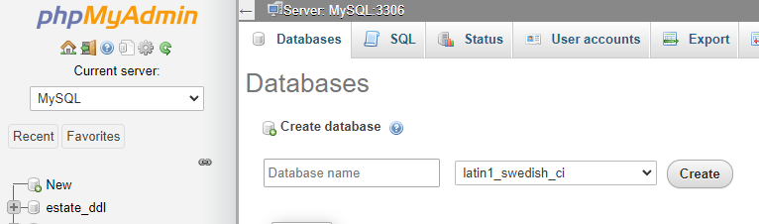

Fig 6

After clicking the database, you can import the SQL file that you have been given to create the database structure, as well as populate it with data. To do this, click “Import” as shown in fig 7. You will then be greeted with the screen shown in fig 8. Here, select “Choose File” as highlighted in fig 8. Then you will need to navigate to the location of the file called Datbase_SQl_file and select it to upload the file and create the database.

Fig 8

Fig 7

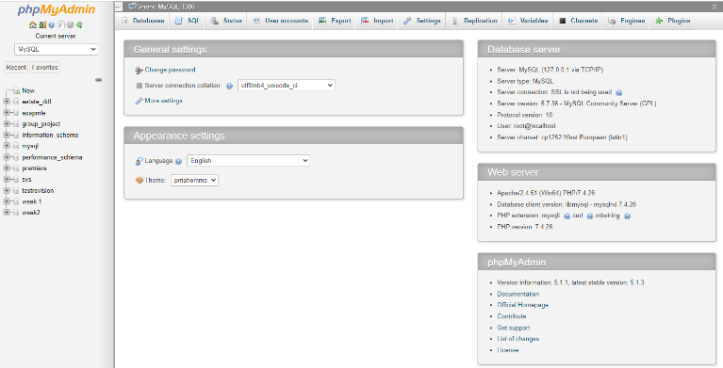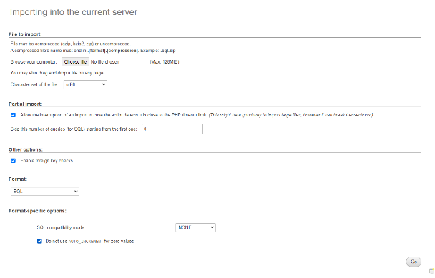

If done correctly, you will have a database with nine tables, each filled with records as shown in Fig 9.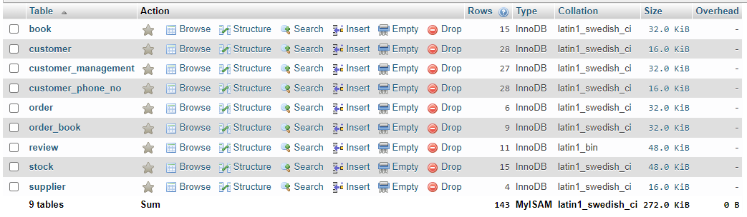

Fig 9

### Logging In and Password Details

The database has two user accounts: a test admin account, and a test user account. This can be seen in fig 10. The privileges granted to the admin account are shown in fig 11, while the privileges granted to the user account are shown in fig 12.

The table below shows the username and password that can be used to login for each of these two accounts.

|  |  |  |
| --- | --- | --- |
|  | Username | Password |
| Test Admin Login Details | Group12Admin | Password01 |
| Test User Login Details | Group12_user | Password02 |

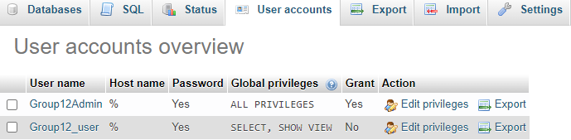

Fig 10

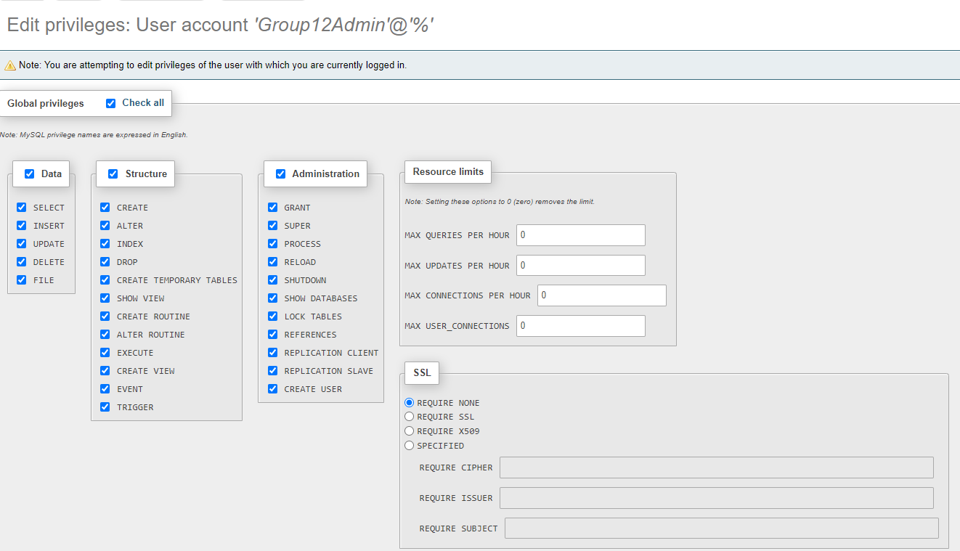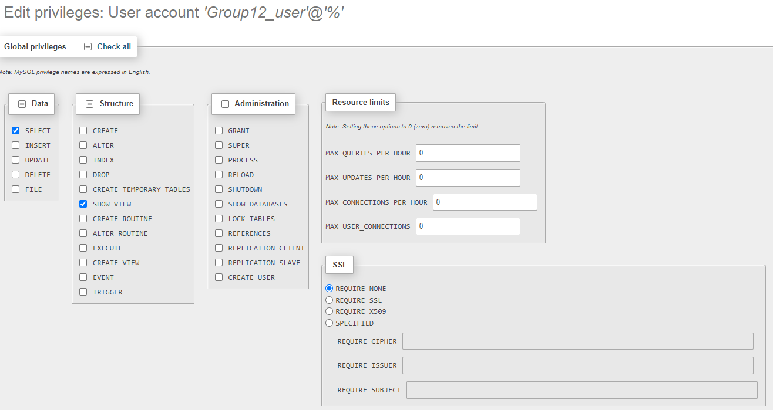

Fig 12

Fig 11

The user accounts described above are imported along with the database. Meaning that after you run the database, you will need to log in with one of these accounts rather than with root as that will not work. The admin account has complete privileges throughout the database whereas the user account can only view it. These accounts were added using phpmyadmin's user management system.

As you have just logged in as root to run the database, you are still logged in as root. If you wish to have admin privileges, logout, and log back in with the admin login detailed above. You can log out using the door icon shown in fig. 13. Once you have logged in as an admin user, you will have complete access to the database. Fig 14 describes logging in with the admin account.

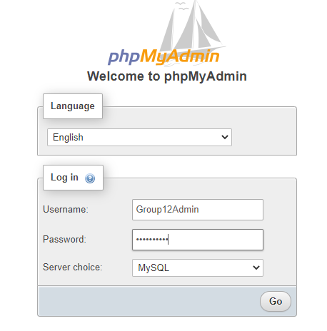

Fig 13

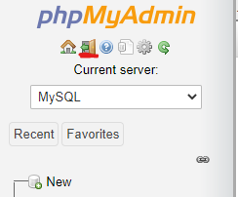

Fig 14

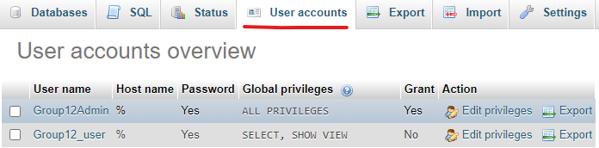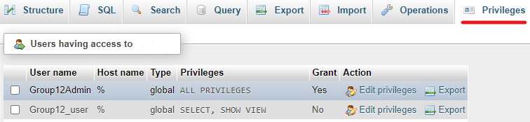Admin users can add user users, as well as edit the settings of already existing users. To add a new user, go to the privileges tab of the database and click new user as shown in fig 15. Here, you can add new users, as well as edit the privileges and login details of already existing users. Alternatively, you can go to the user accounts tab as shown in fig 16 without first selecting the database.

Fig 16

Fig 15

### Optional - Running the Website

After setting up the database, you may also want to use localhost to run the website. Firstly, copy the files that you extracted at the start of this guide and paste them into the www folder within the wamp64 folder on your C drive. Fig 17 shows an example directory to this folder. Alternatively, these files can be extracted into this location at the start of the guide.



Fig 17

If the files are placed in the correct location, you will be able to run the website. First, ensure that WampServer is running correctly, then open your browser and paste the following in the url bar: localhost/COM336_assignment_2022_Group12

This will show you the exported files as seen in fig 18.

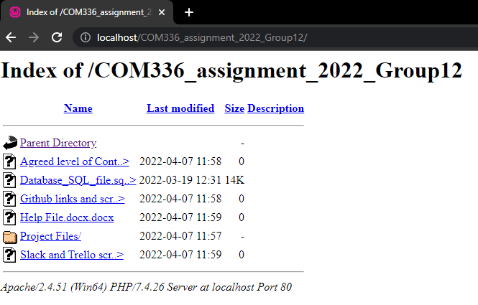

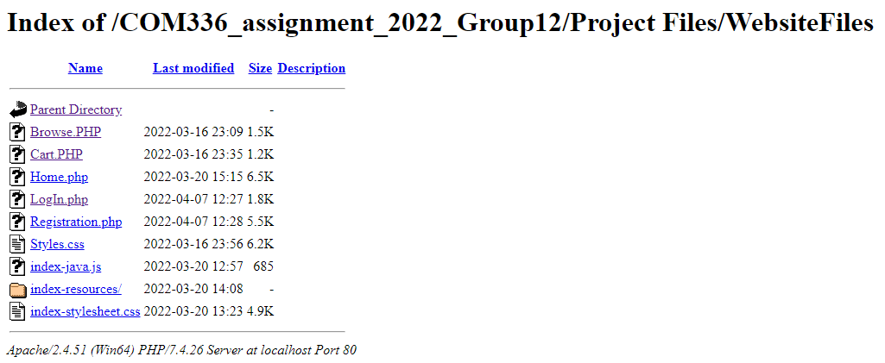

Fig 18

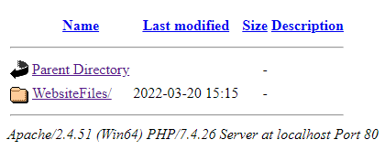

Fig 20

Fig 19

Select Project Files, then Website files (as seen in fig 19), and you will see the PHP files for each webpage as seen in fig 20. Select the webpage that you want to view and it will open.

To view the homepage of the website, click Home.php. Fig 21 shows the homepage that you will see.

Fig 21

### Creating an account and logging in through the website

To log in, or create an account, navigate to the login webpage shown in fig 22 by clicking the Log In button.

Fig 22

You can use this webpage to log into the website by entering the login details of one of the customer accounts held in the customer_management table of the database, then clicking the Log In button. If you instead wish to create a new account, click the textual link that says Don’t have an Account? Register Now! Which will take you to the registration webpage shown in fig 23. If you log in before placing an order, the order will be tied to the customer account that you were logged into when placing the order. Please refer to the section on placing an order through the website below for more information.

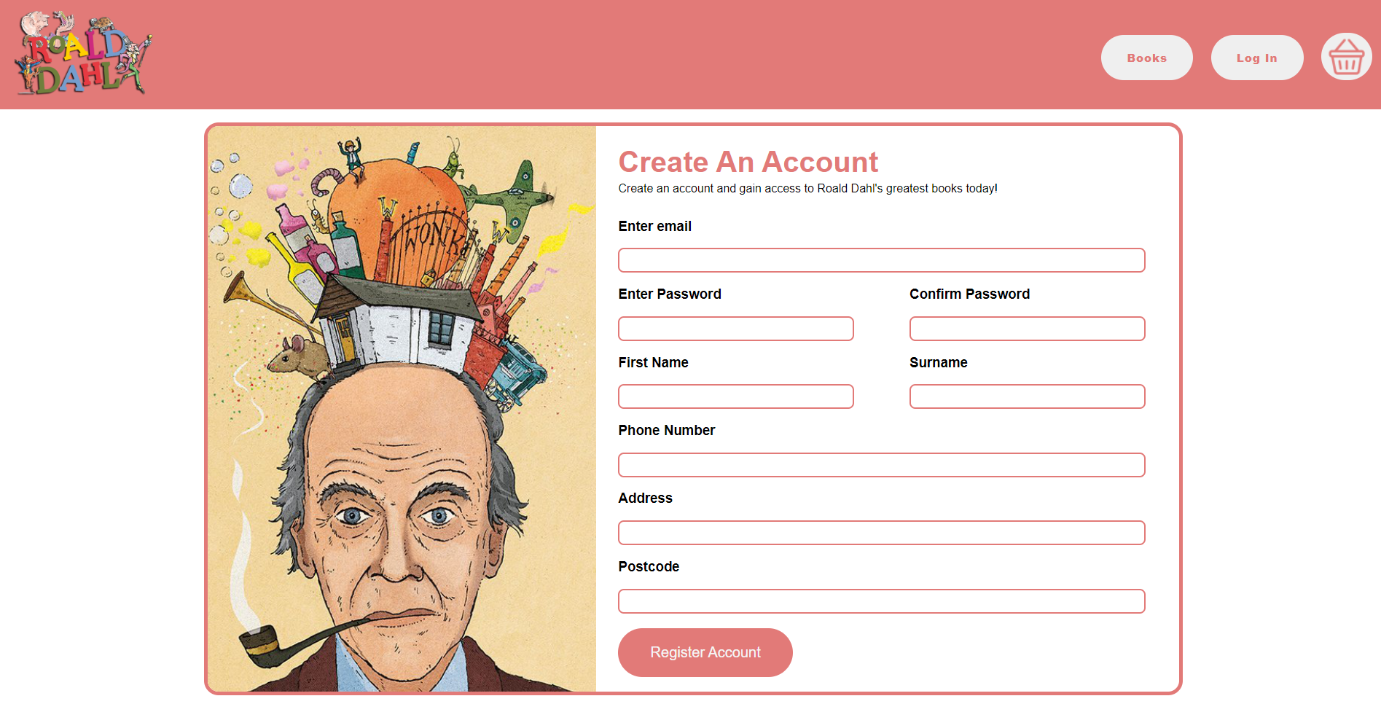

Fig 23

The registration webpage allows you to enter customer details, which will be used to create a new account that will be stored in the customer_management table within the database. After registering a new account, you will be able to login using the login details (email and password) that you entered for the account. You will then be able to place orders while logged in with that account and have those orders associated with that account.

### Placing Orders through the Website

The website implements e-commerce functionality by allowing its users to utilize several webpages to select one or more products and place an order for the product(s). This order that the user places will be stored on the database.

Before users can place an order, they must first decide which items they want to include in the order. This can be done by accessing and browsing the browse webpage. To access the browse page in your browser as shown in fig 24, select Browse.php while in the directory shown above. Alternatively, the browse webpage can be accessed by clicking the Books navigational button while on the home page discussed above.





Fig 24

The browse page allows the user to see all the available products that they can decide between while placing an order. Selecting one of the products will bring you to its individual product page as shown in fig 25, where you will be able to see more details on it and add it to your shopping cart with the click of a button.





Fig 25

Once you have selected one or more products, then added it or them to your shopping cart using the Add to Cart button on the individual product page, you will be available to place an order of the product(s). To see which product(s) you have added to your shopping cart shown in fig 26, navigate to the cart webpage by clicking the shopping basket icon in the navigational menu located at the top of every webpage.

Fig 26

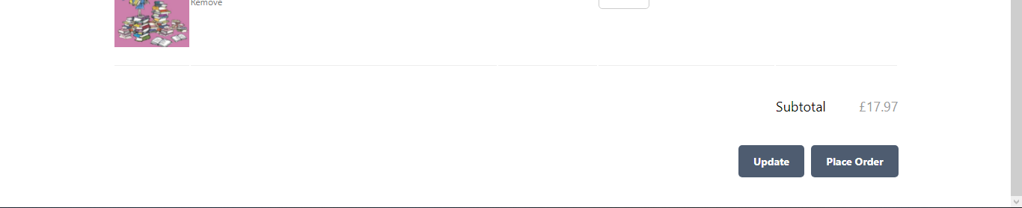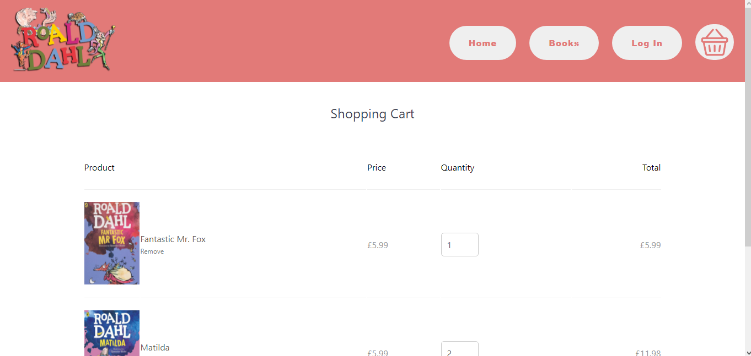

The cart webpage allows you to change the quantity that you want to order of each individual product that you add to your shopping cart. This can be done by changing the value below Quantity. The webpage also allows you to remove a product from your shopping cart by clicking Remove below the item that you want to remove. When your shopping cart shows the product(s) that you want to order along with the correct quantity to order, you can place your order by clicking the Place Order button. This will add your order to the database by adding new entries to the order and order book tables which include all the details of your order. You will also be taken to the place order page shown in fig 27 to confirm that your order has been placed.

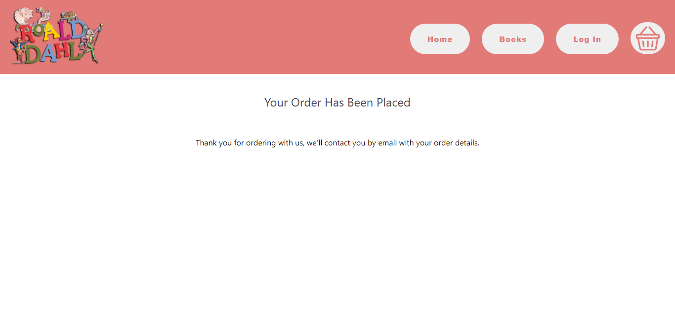

Fig 27

### Overview of the Design Process

#### Database Design

At the start of the project, we had an initial meeting as a group where we decided upon a topic for the project. We decided to create a database for a Roald Dahl bookstore because this would allow us to create a variety of e-commerce related tables, and would transition well into an ecommerce website as the original goal of the project was to develop an ecommerce website. We initiated the design stage by deciding upon the tables that we needed for the project, which then led to discussing the attributes that each table required, as well as how tables interacted with the rest of the tables. At first, we only discussed these ideas verbally, but after that, we created an ER diagram to give an overview of how the database should be structured.

This diagram was then used to create the initial database. We split up database development by giving each member of the group specific tables to create, with one member putting the tables together at the end and checking for any issues that might occur when merging the tables.

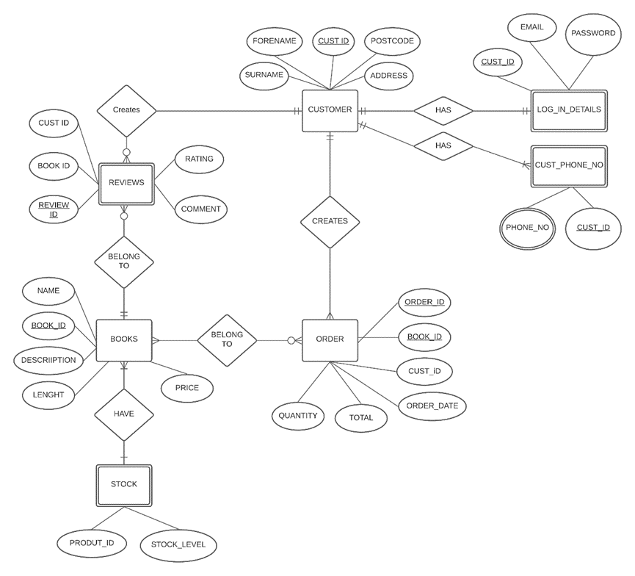

We then discussed the ER diagram as a group, and iteratively made changes to help ensure that it meets the requirements of the required database, and eventual website.

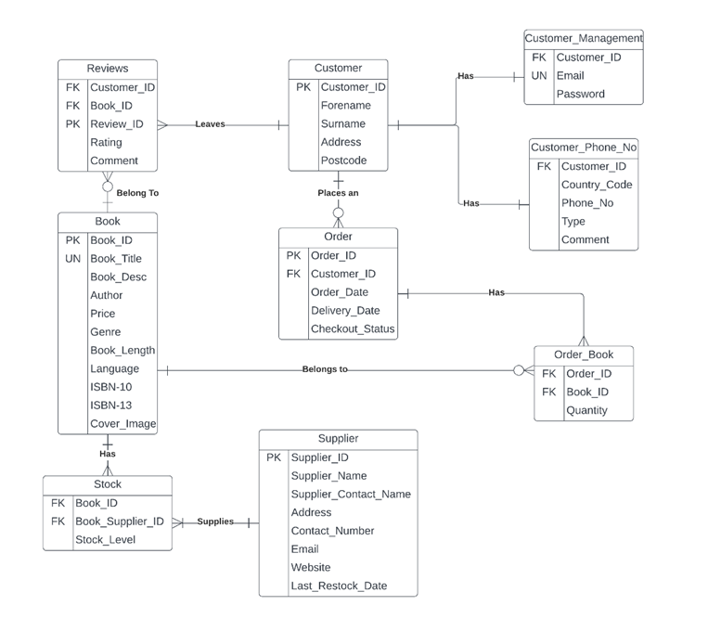

After the database structure was established we entered multiple records into each table. After this was done we created a number of views using DQL. We discussed what information people would find useful to view. These views summarize or pick out select information from each table to help users find information they need.

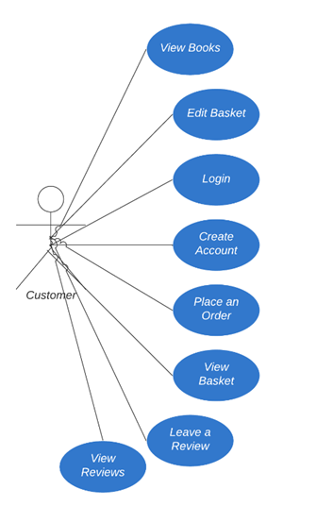

This updated ER diagram allowed us to create the complete database. We made changes to the order table to allow a user to place multiple different books into one order.

We also created a use-case diagram to help identify what features will be required for customers to have a good user experience with the website.

Each member of the group completed a section of the website. Once each section was complete, we were ready to link them all together to create a website.

The website had to work with the database, it had to be able to read and write data from and to the database.

The registration and ordering pages needed to be able to communicate with the database. The login page would read from the customer details and the registration page would write customer details to the database. The ordering pages would write order details to the database.